CIS 3020 Progress Report
Jose Villeda
Week 10
Project name: Billing Dashboard for an Independent Language School
Brief description and its purpose: A dashboard that allows students to access information related to their course content but mostly focused on handling billing transactions such as requesting statements.
Target users: Language learners that attend the school.
Current Project Status
o What is implemented and working: Login form that submits a POST request into a backend server and then into a database and creates a user session.
o What is partially implemented: User count based on the amount of account in the database, that have the “standard” role. Administrator/Standard user redirections; I have yet to implement different webpages for these roles
o What is not started yet: Mock-payment system; an implementation to perform payments with mock-wallets.
What Has Gone Well
o Tools or concepts that were easier than expected: Password hashing was easier than expected, what took most of the time was verifying that hashes were getting stored correctly and authentication remained unbroken rather than the feature itself.
o Features or tasks completed successfully: Redirection when user credentials are submitted correctly and denying access to private files without authentication (real database instead of a mock-database stored in an array).
Challenges and Problem Solving
o Technical or conceptual difficulties: Establishing a connection with the database became complicated since the instructions to do so were not as clear (at least for me), but afterwards I was able to find a single command that made the process simpler in Render’s documentation.
o How you attempted to solve them: Always tried using logic first and if I could not figure it out in my own, reading documentation and showing AI my error boxes or places where I was stuck in order to solve it.
o What you learned from the process: I learned how websites interact with a database as well as basic user authentication, like verifying if a user exists or not, providing feedback to the user with these features. IMPORTANT: when learning how to write SQL queries in Node, I also stumbled upon unintentionally leaving an SQL injection vulnerability within the website’s backend, and learned how to fix it afterwards
• Next Steps
o Specific tasks planned before the next checkpoint: Separating administrator from user pages and restricting features depending on the role.
o Short-term development goals: User session improvements to have more stable cookies and session IDs that remain constant during a same session, mock-payments and a mock-wallet to simulate transactions.
• Resources and Tools Used
o Tutorials, websites, documentation:
- Anson the Developer’s Express.js Tutorial Playlist: Express JS Full Tutorial Playlist 2024 - YouTube
- Express.js official documentation
- Varied YouTube tutorials for specific topics
o AI tools (if used) : Visual Studio Code’s AI feature to generate commit messages to GitHub.
o Other people or sources of help: n/a
• Generative AI Use (If Applicable):
- ChatGPT
- Google search automated AI responses
o What you used AI for: Error correction, used AI to guide me in the right path to implement the ideas as well as helping me stay consistent with tasks and not jumping onto other features. Teacher with different Node features such as bcrypt.js
o What you did yourself: Database connection that wasn’t working according to AI’s instructions, real documentation was the solution instead. Error codes and feedback.
o Screenshots of prompts used (included as images or appendix)

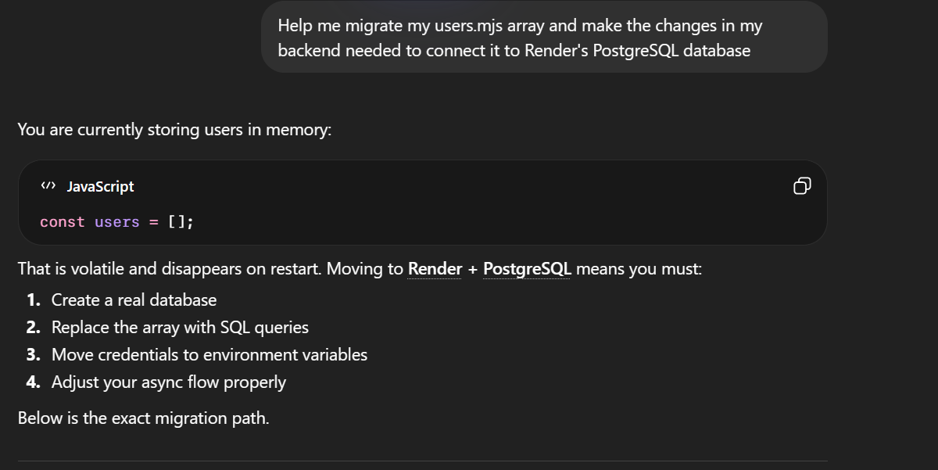

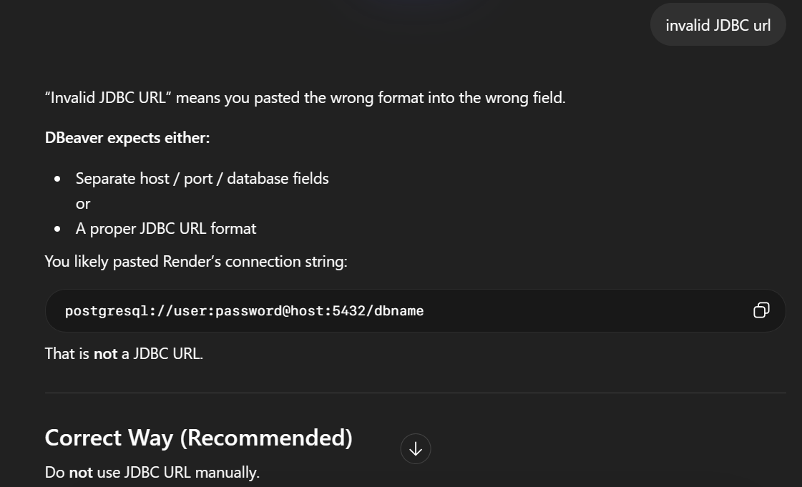
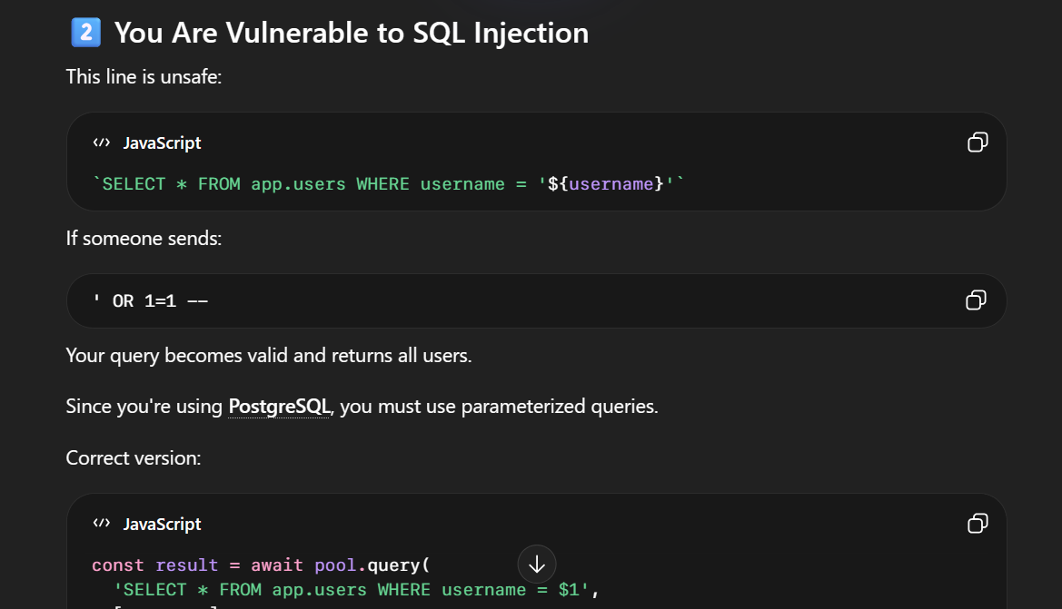
• Links
o GitHub repository:
https://github.com/marinimaster/cis3020project/settings/pages
o Live site (if applicable):
https://marinimaster.github.io/cis3020project/
o Any relevant demos or documentation: Windows subsystem for Linux was an essential tool to install features like Nodemon, Node and Express.

